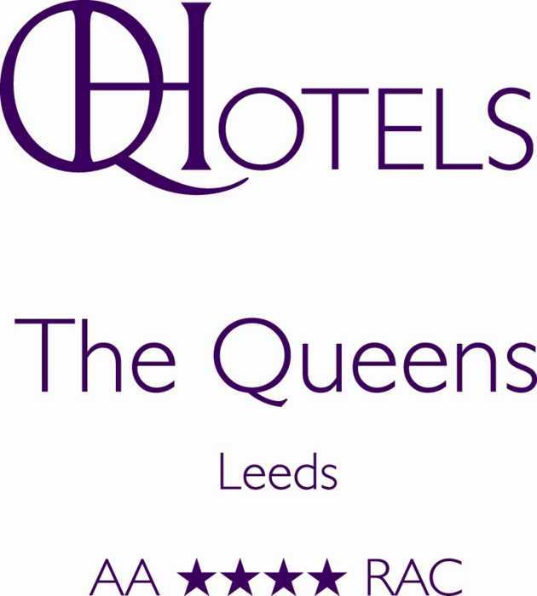

You are invited to pre-order your wine for the
Insurance Institute of Leeds Annual Dinner
on
Friday 3rd November 2017

Please e-mail by return to abramall@qhotels.co.uk

NAME OF HOST & COMPANY: _____________________________________________
CONTACT TELEPHONE NUMBER: __________________________________________

To ensure wine orders are processed, please make sure that they are returned no later than 7 days prior to the event.

Name of Wine | Quantity | Price | Total
Package A |  | £52.00
Package B |  | £41.50
Package C |  | £28.50
Sparkling water |  | £4.25
Still water |  | £4.25
TOTAL
Pre-payment of all orders is required before the event. Account to company facilities will only be offered to those currently holding a credit facility. Accounts previously granted credit but not used in the last 3 months will need to be renewed. Credit applications will take 2 weeks to process. Company cheques are not accepted for payment. All pre-ordered drinks are to be pre-paid. Insufficient information may result in non-processed orders.

*** PLEASE COMPLETE PAYMENT DETAILS ON PAGE 3 ***

BAR TABS
If you would like to open a bar tab for the evening, please sign below with authorised signature and credit limit. You will need to collect your tab card from Reception on arrival. Bar tabs can be opened without pre-ordering any wine.

Signature:_________________________________________________ Credit limit £:_____________

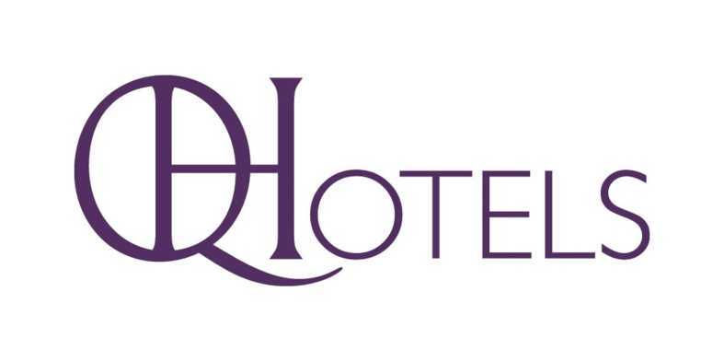

The following drinks packages are available

Package A

A selection of 15 bottles of beer £52.00

Package B

A selection of 12 bottles of beer £41.50

Package C

A selection of 8 bottles of beer £28.50

Prices are inclusive of VAT at the current rate

To ensure that wine orders are processed, please make sure that they are returned no later than 7 days prior to the event

THIRD PARTY AUTHORISATION
I hereby authorise QHotels to debit my Credit / Debit card for the charges incurred by the following guest(s). (A)
Name of Group/Guest(s) charges benefiting: | Reservation Number(s):

(*)Arrival Date: (DD/MM/YYYY) Departure Date: (DD/MM/YYYY)

(B) All fields marked with (*) are mandatory fields.
Please tick the applicable charges you, as credit card holder, will accept:

Room Rate: 
All Charges: 
Charges to the value of:  £
Other:  £

(Please specify):
(C) Card Holders Details:
(*) Card Holder’s Name:
(*) Card Holder’s Signature:
(*) Billing Address:
(*) Postcode: (*) Tel/Mo Number:
(*) E-mail:
(*) Type of Credit Card: (Please circle) Visa / MasterCard / Amex / Diners / Other: (Please note):
(*) (Please circle): Credit Card / Debit Card
(*) Credit Card Number:
(*)Start Date: (Maestro Only MM/YY) (*) Expiry Date: (MM/YY) (*) CVV:
(*)Card Issuer (E.g. Barclays) (*) Country of Issue:
PLEASE PROVIDE A TRUE PHOTOCOPY / SCAN OF THE FRONT & BACK OF THE CREDIT CARD TO BE CHARGED on returning your third party authorisation form. Without this, we will be unable to process the transaction.
(D) If you wish to pay by BACS our bank details are below, payments to be received at least 24hrs prior to arrival
Bank Name: Barclays Branch Name: Pall Mall, London, SW1A 1QA
Sort Code: 20-65-82 Account Name: The Queens Hotel Limited Account Number: 60872040
Please provide your Reservation Number and Name of Guest booking in the reference section, when processing the BACS transfer online.

Please send completed form by fax, post or e-mail, 24hrs prior to guest’s arrival to:
The Events Department, The Queens Hotel, City Square, Leeds, LS1 1PJ
Tel: 0113 391 7234, Fax: 0113 391 7354, Email: Queensevents@qhotels.co.uk

Terms & Conditions
CVV Code: (3 digits on the back of your card) THIS CODE IS REQUIRED TO VERIFY CREDIT CARDS. FAILURE TO SUPPLY WILL RESULT IN THE CREDIT
CARD AND AUTHORISED CHARGES BEING DECLINED.
A third party authorisation form will not be accepted on the day of arrival, we require 24hrs notice for any third party authorisation to be processed.
FAILURE TO PROVIDE THIS INFORMATION 24hrs PRIOR TO GUESTS ARRIVAL, AS REQUIRED WILL RESULT IN GUESTS BEING ASKED FOR AN ALTERNATE METHOD OF PAYMENT ON ARRIVAL.

