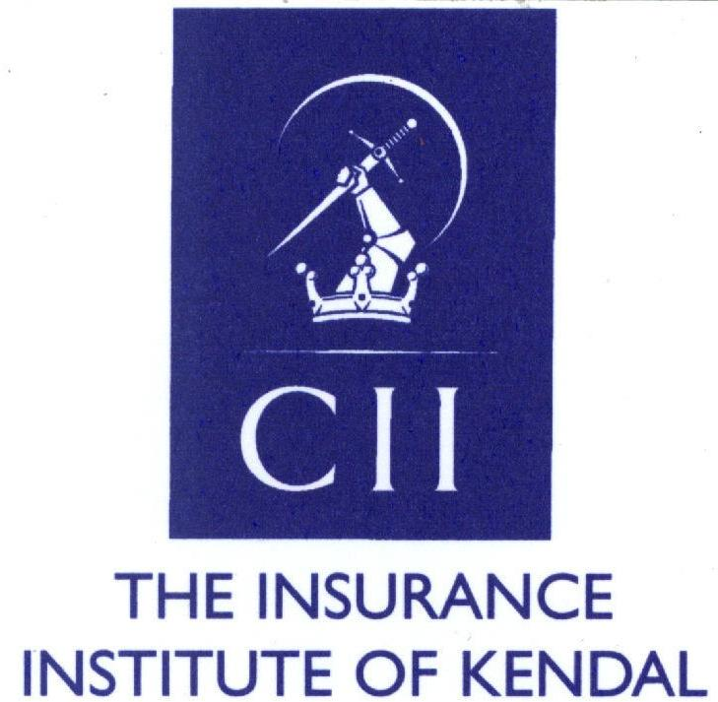

Minutes of the Annual General Meeting of the Insurance Institute of Kendal held on Thursday 5th May 2016 at 6.50pm at Crooklands Hotel

In attendance – Cath Evans (Chair); Ewan Scott (Hon Treasurer); and nine members of the Institute

1. Apologies: John Calvert; Janet Warriner

2. Notice convening the meeting: It was unanimously agreed that this could be taken as read, the notice having been circulated previously be the Hon Secretary.

3. Minutes of the previous AGM: The minutes of the previous AGM were circulated and it was proposed by Ian Callaghan that they be accepted as a true record. Ewan Scott seconded this proposal and it was carried unanimously.

4. Matters arising: None

5. Annual Accounts: The Hon Treasurer circulated copies of the audited Annual Accounts. The Hon Treasurer advised that the Dinner Secretary had discovered that one party had not yet paid for their dinner tickets. This was being pursued and a further £400 was expected to be received shortly. This would significantly reduce the loss on the Annual Dinner to £490.15. Following a few points of explanation/clarification, John Regan proposed that the Annual Accounts be adopted. This was seconded by Cath Evans and was carried unanimously.

6. Financial Recommendations: It was proposed by Cath Evans and seconded by Ian Callaghan that the Financial Recommendations for the year 2016/17 should remain as before and any alterations to be at the discretion of the Council. This proposition was carried unanimously.

7. President's Report: The President was not present and did not submit a report for consideration.

8. Council's Report: The Hon Secretary was not present and did not submit a Council's report for consideration.

9. Election of Officers: President: Cath Evans was proposed by Ewan Scott; seconded by John Regan and carried unanimously.
Deputy President: Ian Callaghan was proposed by Cath Evans; seconded by Ewan Scott and carried unanimously.
Vice Presidents: Janet Warriner, Ewan Scott, John Calvert, John Regan & Ian Callaghan were proposed by Cath Evans; seconded by Donna Cokell and carried unanimously.
Hon Treasurer: Ewan Scott was proposed by Cath Evans; seconded by John Regan and carried unanimously.
Hon Secretary: Donna Cokell was proposed by Cath Evans; seconded by Ian Callaghan and carried unanimously.
Charities' Representative: John Regan was proposed by Ewan Scott; seconded by Ian Callaghan and carried unanimously.
Council Members: Tim Parsons, Mark True, Martin Osborne, Stuart McGurk, Alex Clegg & Hannah Speakman were proposed en bloc by Ian Callaghan: seconded by John Regan and carried unanimously.
North West Representative: Cath Evans was proposed by Donna Cokell; seconded by Hannah Speakman and carried unanimously.

Appointment of Auditors: Knox Accounting was proposed by Ewan Scott; seconded by Ian Callaghan and carried unanimously.

10. Any Other Business: It was proposed by Cath Evans that a new position of Deputy Dinner Secretary be established. This was agreed and Alex Clegg was proposed by Ewan Scott; seconded by Ian Callaghan and carried unanimously.

It was further proposed by Cath Evans that a new position of Young Members' Representative be established. This was agreed and Hannah Speakman was proposed by Donna Cokell; seconded by John Regan and carried unanimously.

The date of the Annual Dinner for the forthcoming institute year was agreed as Friday 27th January 2017 at The Netherwood Hotel, Grange-over-Sands. Council members were asked to note that this is a month earlier than the usual date for the Annual Dinner and that they should start to spread the word within their respective networks.

It was agreed unanimously that Cath Evans and Donna Cokell should attend the 2016 CII Network Conference.

The date of the next AGM was agreed as Thursday 4th May 2017 at a venue to be agreed.

11. Investiture of New President: The incoming President, Cath Evans was presented with the Presidential badge.

12. Presentation of Past President's Bar: The outgoing President was not present to receive the Past President's bar.

There being no further business, the meeting was formally closed at 7.45pm.

