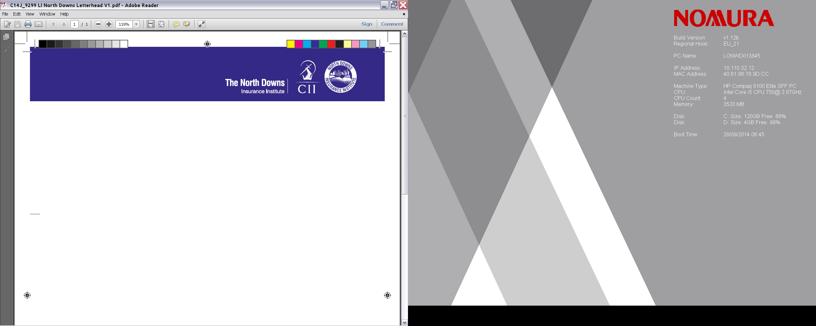

LUNCH TALK – THURSDAY 16TH MARCH 2017 at
THE MILLINERS ROOM, HARLEQUIN THEATRE, WARWICK ROAD, REDHILL RH1 1NN.
Times 12.30 -14.00hrs (buffet lunch @ 12.00hrs)
DATA PROTECTION ACT

Presented by Richard Galley – Searchlight Training

About this Lunch and Learn
The Data Protection Act controls how personal information is used by organisations, businesses or the government. Everyone who is responsible for using data has to follow strict rules called ‘data protection principles’. This session will consider the Data Protection principles and the importance of information security within the General Insurance sector.

Learning objectives
At the end of this event, the delegate will be able to identify:
- articulate and apply the 8 Principles of Data Protection to their own business and determine the degree to which they are achieving compliance

- understand the importance of information security

- start formulating robust plans for establishing or refreshing measures within their own business intended to hold personal data securely

- start to build a basis for reviewing business performance in relation to Data Protection requirements and building this into the regular risk assessment process

- react positively and correctly to a ‘Subject Access Request’

The Speaker – Richard Galley
Richard worked for over 20 years for BUPA, where he was their Head of Compliance and Policy Development. He is one of Searchlight’s senior regulatory consultants and delivers a range of regulatory/compliance training.

to book your place email to :- Administration Officer at ;-
davejp121 @gmail.com
Note:- the number of spaces for this talk are limited and early registration is recommended to avoid disappointment.
1.5 hour’s CPD can be claimed for this event if relevant to your learning and development needs. Visit www.cii.co.uk/cpd for more information


