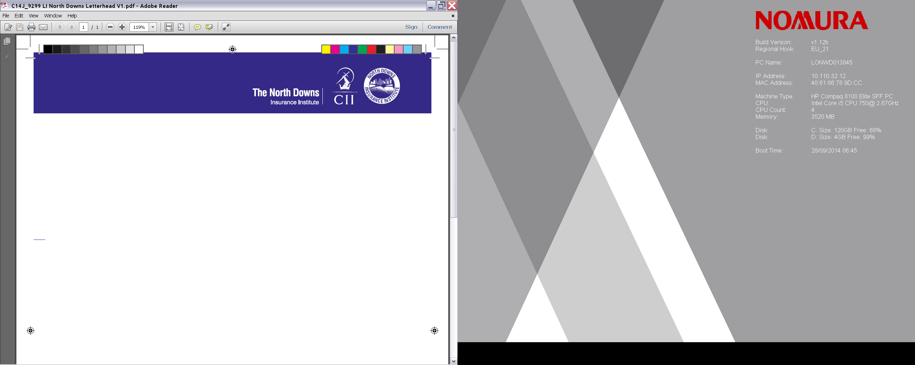

TRAINING SESSIONS – WEDNESDAY 1st MARCH 2017
EXAM REVISION –‘how to revise effectively for the CII exams’

To be presented by Grace Maxted LLB (Hons) ACII

This talk will cover the following learning objectives:

- To develop an understanding of the CII exam structure and the exams available under the CII programme.
- To become familiar with the format of a multiple choice exam.
- To learn how best to prepare for the exams and structure your revision.
- To pick up some learning tips and learn how best to navigate the CII books.
- To gauge how best to approach coursework for the higher level exams.

There will also be the opportunity to ask any further questions over coffee.

The Speaker –Grace Maxted LLB (Hons) ACII
Grace has worked in the London Insurance Market for over 12 years and delivers a number of CII foundation courses. Grace’s background is claims adjusting, having worked for various insurers within the market, predominately on financial lines, professional indemnity and general liability claims.
Grace obtained her ACII and law degree whilst working full time and is now a freelance training consultant and insurance contractor. Grace has also lectured for CASS Business School and ALARM Risk Conferences.

NOTE - Two separate presentations have been arranged for this event, as follows;
1. Bromley :- Direct Line Insurance, Churchill Court, Westmoreland Rd,
Bromley. start 9.00am (registration 8.50am) – end 10.30am

2. Croydon :- Zurich Insurance, Sunley House, Bedford Park,
Croydon. Start 12.00pm (registration 11.50am) - end 1.30pm
To book your place email to :- Administration Officer at
davejp121 @gmail.com
when booking please ensure that you indicate which Session you would like to attend.
1 hour’s CPD can be claimed for this event if relevant to your learning and development needs. Visit www.cii.co.uk/cpd for more information

