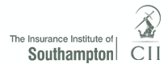

2016 Achiever Award Nominations ........ now open!

1st Prize £150

2nd Prize £100

3rd Prize £50

The award is to publicly recognise and applaud the outstanding achievement of rising stars within our local Insurance and Financial Services Industry

(Geographical area includes Southampton, Portsmouth, Salisbury & Andover)

Do you know someone who fits the following criteria?

- Under the age of 35 at 1/1/16

and

- has made a considerable contribution to increasing “Insurance Professionalism” within the local institute area or the local community or
- has demonstrated outstanding performance within their role or
- can demonstrate a commitment and achievement towards their own personal and professional development

To find out how to nominate your staff please visit the Insurance Institute of Southampton website and watch out for our 2016 Achiever Award Mail shot including nomination forms

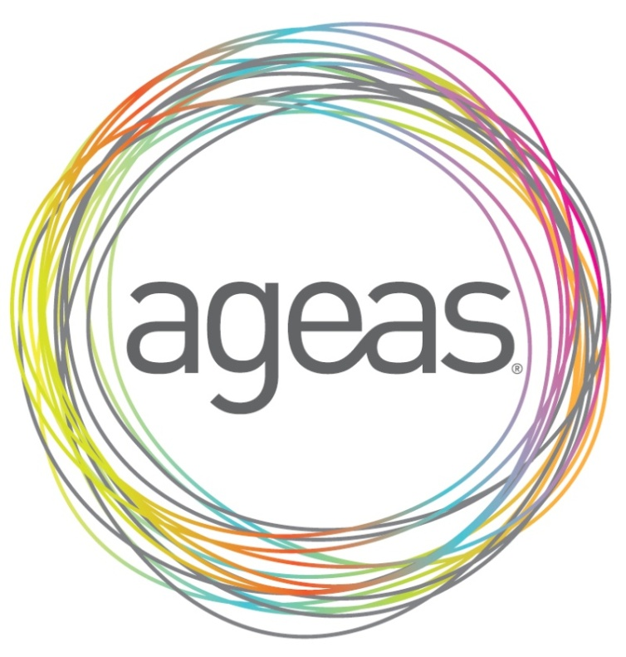

Sponsored by Ageas (UK) Limited

