Submission Rules
Before commencing work you need to fully familiarise yourself with the ‘Candidate coursework assessment guidelines and instructions’, including:
- Maximum word limit for assignments (3,200 words)
- Font type and size to be used in your assignments (Arial – size 11pt)
- Rules relating to referencing third party work
- Penalties for contravention of the rules relating to plagiarism and collaboration
- Deadline for submission of coursework assignments
- Outline of the marking criteria applied by assessors to submitted assignments
Important notes
Ensure that you have:
- Answered all parts of the question in sufficient depth
- Answered the precise question as worded – marks will not be awarded for irrelevant material
- Correctly referenced all sources shown on the reference list in your answer
- Checked your word count to ensure it is not too low as this might indicate that you are not answering in sufficient depth and will affect the marks allocated for components in the mark-grid. A word count that is too high may lead to lack of focus
- Reread your answer to ensure your description of the context is not too long as marks are only allocated for answering the question
- Reread your answer to ensure it is logically structured and that you have added value by making sufficient conclusions and recommendations
- Failure to follow the guidance and instructions could result in you failing this unit

To be completed before submission:

Word count: | 3,161

Start typing your answer here:
This essay will aim to examine how regulation, indeed regulators themselves, are continually evolving from the somewhat disparate collection of regulators in the 1990s, to the formation, following the Financial Services and Markets Act (FSMA) 2000, of a cohesive body, the Financial Services Authority (FSA), then following the Financial Crisis in 2007-9, a separation of the FSA into the Prudential Regulatory Authority (PRA) and the Financial Conduct Authority (FCA) which came into operation in April 2013. The implications for insurance organisations will be described. As the FCA is a new entity, this essay will assume that much of what was required of the FSA by the FSMA will be required by the FCA.
The essay will then explore how two external issues the organisation and its responses to these regulatory/external issues and demands presented will be described and explained where applicable throughout the essay.

Regulation is designed to “Control or maintain the rate or speed of a process so that it operates properly.” Regulators exist to “Control or supervise company/business activity by means of rules and regulations.” Within the insurance industry, the purpose of regulation is to create and maintain an effective, efficient marketplace where:
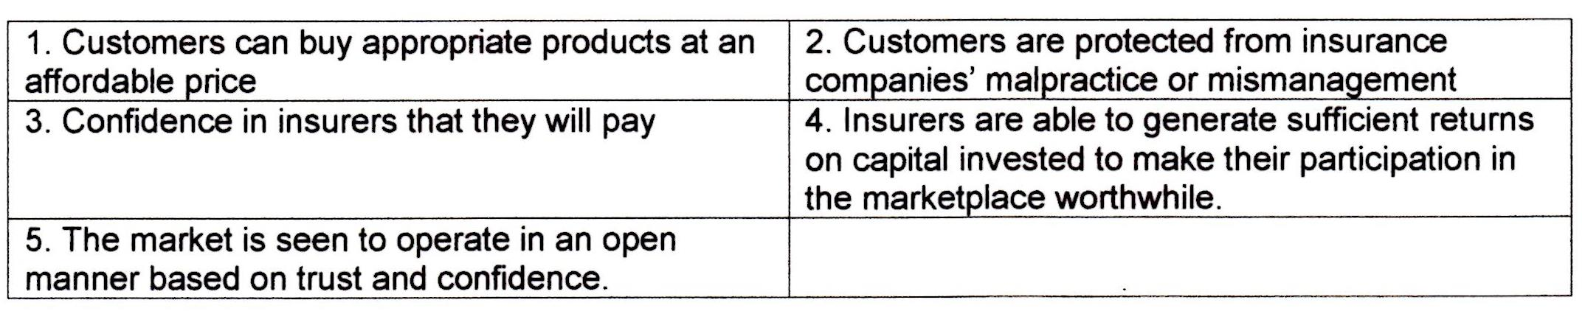
In order continually to ensure customers and the marketplace are satisfied that these standards are being upheld; regulators must continually review and revise their principles/rules and what sanctions to impose on transgressors. John Tiner, FSA Chief Executive (2005) wrote “We do not hear arguments against the existence of regulation…but we do hear extensive debate about how regulation is conducted,” this shows that the FSA and no doubt the FCA are receptive to feedback from governing bodies (e.g. UK government, EU commission), the UK financial services industry and customer lobby, as part of their review process. Our organisation must be nimble enough to adapt and comply with any changes the regulator requires, without adverse effects on balance sheets.
The high level requirements by the FSA for Managing Agents operating in Lloyd’s are to:
As will be demonstrated in subsequent paragraphs, there is something of a regulation cycle; regulators try to reflect political desire to regulate tightly, while appeasing public and industry concerns about over-interference. The result is a ‘pendulum effect’:

Prior to its inception, and in the first two years of the FSA’s existence, insurance regulators followed a ‘one size fits all approach’ with limited reference to actual risk presented by individual firms. This made the application of rules to individual firms difficult, and it was unclear how best even for the most proactive firms to implement them. In 2003 the FSA announced it would adopt a more flexible, risk-based approach to the regulation of authorised firms. This was a consequence of the Basel II framework, devised by the Basel Committee on banking supervision, and promoted by the FSA and the International Association of Insurance Supervisors (IAIS) in order to harmonise insurance regulation globally. This framework aimed to ensure that there is adequate capital in regulated firms through the application of risk management. The implications for our firm included routine monitoring visits and recognition of the respective responsibilities of the consumer and the firm’s senior management. From an insurance perspective seeking to remove all risk of failure from the financial system is undesirable because Insurers differ from banks. Banks want to get rid of risk: insurers want to take on risk and make money out of it. The risk based approach was therefore designed to enable the FSA to identify, and take mitigating action in respect of significant risks to their objectives, while not preventing failures.
Our organisation has adapted to the way risk influences the nature of regulation i.e. what is covered, the way in which the regulator conducts itself and how it looks at each firm. The effectiveness of internal controls, internal capital assessment and risk management systems are all examined and so the onus is on us to document the identification and management of risk and the establishment of appropriate control systems. This disclosure of information will be used for comparing firms in order to promote discipline, though, as the data management section of this essay will show, this must be done diligently.
In 2006 the FSA became less prescriptive, concentrating on general principles rather than detailed rules with the intention of reducing bureaucracy, therefore lowering cost to both FSA, and authorised firms in the way they showed compliance, thus resulting in lower prices and better value-for-money customer service.
The result of ‘high-level’ principles for insurance organisations was that decisions were pushed up the organisation structure, placing more pressure on senior management: “the more overt responsibility will…represent a new and difficult challenge and the senior management will need the experience and insight to make sound judgment calls and be willing to accept the responsibilities,” This impacted job security of senior management, especially if sanctions were placed upon the firm..
The financial crisis, peaking in 2008, caused criticism of the ‘laissez-faire’ style of regulation that had been adopted; regulators around the world were considered at fault for ‘allowing it to happen’. The pendulum / knee-jerk response to this was to introduce a more intrusive, assertive regulatory approach entitled “Outcomes-based regulation” The FSA changed emphasis away from examining words/intentions, to whether the right thing is actually delivered to the customer/market/regulator. The implication for us has been to ensure that we demonstrate our proactivity and actions, not just words.
The FSA’s move from rules-based, to risk-based, to principles-based regulation (and now outcomes-based regulation) as well as taking over the responsibilities of a dozen specialist regulators led to calls from some trade journals to suggest it was overstretched, “always likely to focus on consumer protection than prudential regulation.” This could explain the separation of the FSA into the FCA and PRA
The FCA are likely to continue with the regulatory approach adopted by the FSA in 2008 going further in for how they convey their requirements i.e. even more rule-based. The FCA will adopt an assertive, interventionist approach in order to stamp out bad practice early before it becomes a major issue.
The FSMA requires the FSA/FCA to adhere to six principles of good regulation, which impact how they, and indeed regulated entities, are organised/run:

1 Efficiency
2 Role of Management
3 Proportionality
4 Innovation
5 International character
6 Competition

Throughout its ‘reign’, the FSA has had a handbook with a High Level Standards section which applies to all financial firms and the more specific Insurance Conduct of Business Sourcebook (ICOBS) which must be followed by all organisations selling or giving advice on insurance products. Within the handbook, exists the Principles for Businesses (PRIN) which formalise ways to operate (which should already be part of any well run business). The implications to our organisation are again to ensure that procedures are documented that they are being adhered to.

These principles and their implications are displayed below:
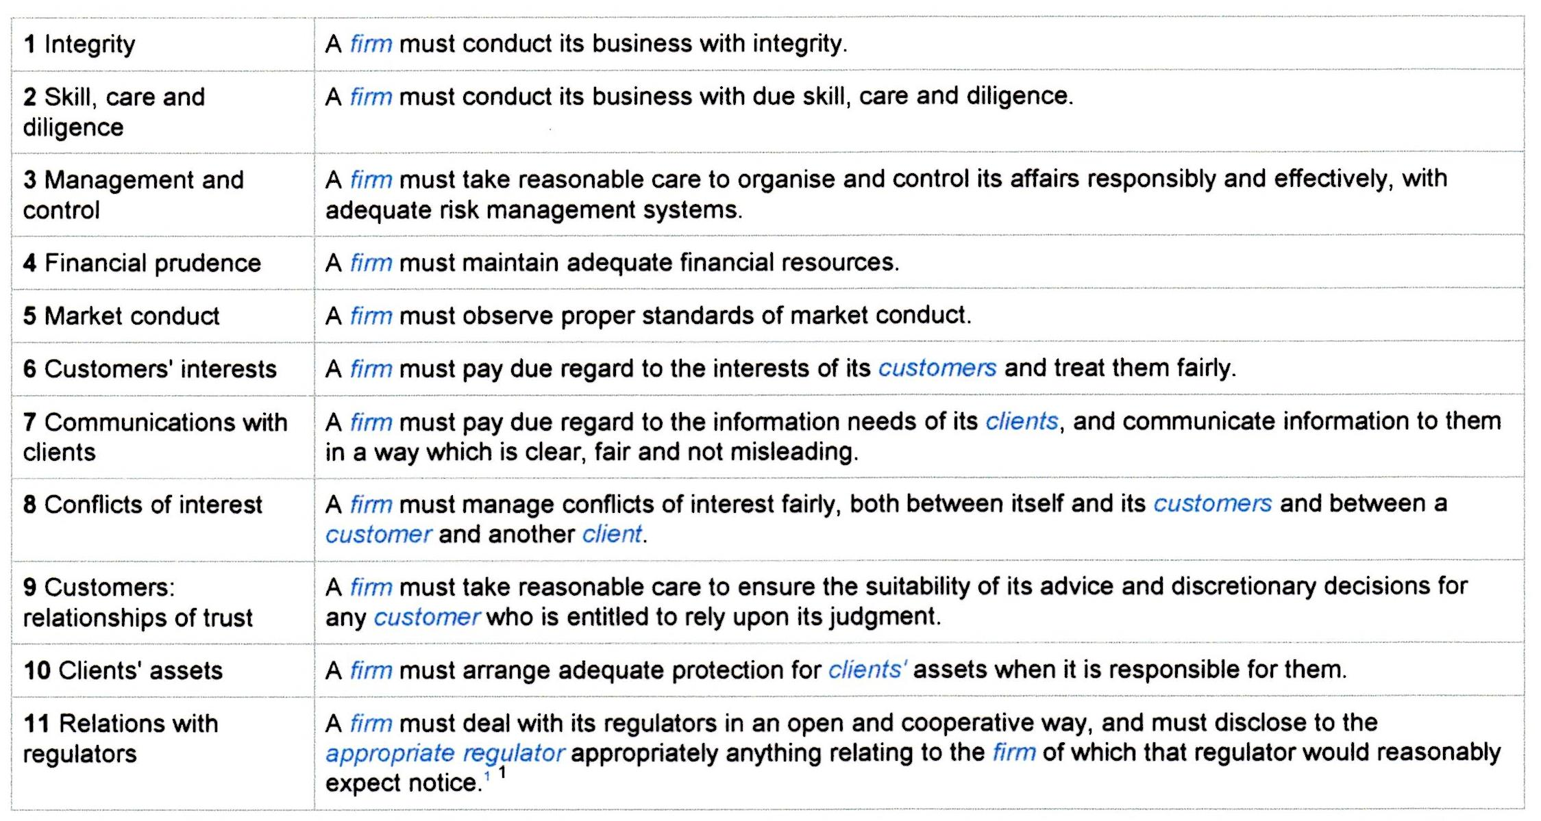
Principles 6-8 were grouped latterly into the TCF (Treating Customers Fairly) Principle as well as an expansion of Principle 2, TC (Training and Competence), with the implications on us including a demonstration of:

Some of the measures we have taken include:
- internal user guides when joining the company,
- Mid-year and year-end reviews for all employees
- New employees joiners have a 6-month probation period where they are reviewed twice (please refer to assignment 2 for details on the review system / balanced scorecards etc).
Our firm has gone above and beyond what is required by regulators:
- 2012 - Prerequisite that anyone applying for management positions must be ACII qualified.
- All client and market facing employees completing the OIL Accreditation by the end of 2013
- All those broking in the Lloyd’s market complete the LLMIT/LM1/LM2 certificates within 12 months of starting.
This section has shown the pendulum of regulation shifts regularly, with more arduous implications on our firm when regulators have tightened rules or made them more prescriptive and detailed. Conversely, in times of a ‘softer touch’ from regulators, the implications on us are less demanding (though the responsibility often rests with senior management, rather than every individual within the Company).
A consequence of the Credit Crunch has been the realisation by regulators that the reputation of the insurance industry is dependent on the corporate behaviour of individual firms within it. This has led to an examination of ethical practice; the CII has issued a Code of Ethics and Conduct to aid this and can take disciplinary action against firms who do not comply). Employers must set their own in-house rules to meet the expectations of stakeholders, particularly clients and regulators.
Companies can either follow ‘strictly legal’ policies which have advantage of clarity in following the ‘letter of the law’. This can be slightly amended to follow the ‘spirit of the law’ which will be based on how the law has been interpreted in past cases. The second method takes the ‘ethical best practice’ approach. This has come under criticism if companies/individuals abuse this: “Following the Big Bang in 1986…The City became more competitive and less honest.” “Any behaviour is acceptable provided that it is not specifically proscribed by regulation…some professionals are (even) actively looking for loopholes in regulation to extend the limits of what they can do.” The response is that regulations have to be increased in volume and complexity to prevent this.
The implications and subsequent efforts by our firm to show compliance are shown below:
- Ethics Policies – While we adopt an ‘ethical best practice’ approach
- Statements of Values
- Employment Contracts – Issued to every employee for review and signature before the course of employment starts. Expectations and Disciplinary action for transgression are laid out in this document
The CII has assisted in developing firms’ Corporate Social Responsibility compliance by developing a framework for professionalism, encompassing training, qualifications, continuing professional development (CPD) and consumer redress. In 2010 The Aldermanbury Declaration, was published, to be implemented by 2013, which we have done ahead of many other brokers.

The implications for insurance organisations manifest in the prescription of four principles:
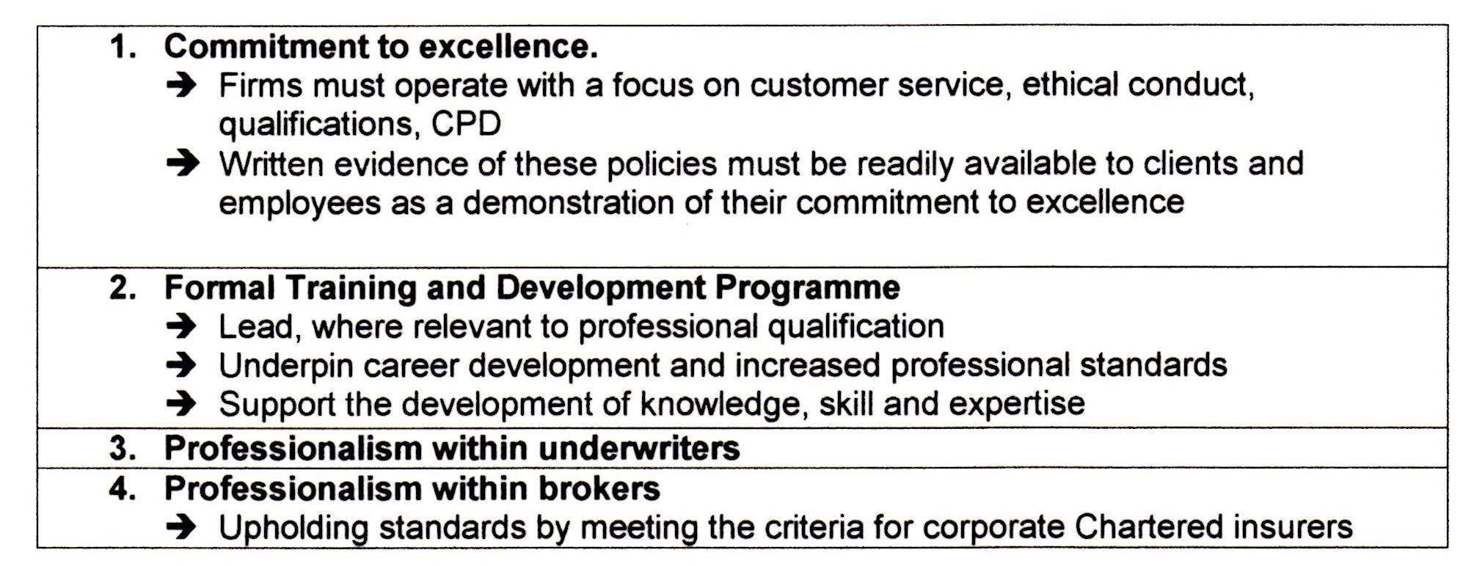

Our organisation has established CPD sessions in the form of departmental ‘Lunch and Learn’ lectures where senior members of the practice speak about integral areas of the business area. Attendance to Lloyd’s lectures is also actively encouraged. Formal training is often outsourced to consultants. Professionalism is upheld in the adherence to in-house ethics and management publications. We also place great emphasis on behaviour management and promotes “soft” skills training in fields such as:
- Maximising business relationships
- Communication Skills
- Leadership
- Presentation Skills
A firm’s compliance to Good Corporate Citizenship extends to its own employees as well. Though regardless of regulatory sanctions, the potential reputational damage caused by poor pay, working conditions, work-life balance etc. would likely result in our being unable to recruit the best candidates. Our firm works hard to ensure salaries are competitive, while offering a strong pension programme, health insurance and 26 days paid leave to be taken per year (the number rising with years of service).

----------------------------------------

The two major external issues to be the focus of this essay will surround:
- Data Protection (and resultant IT and Data Management rules)
- Bribery.
As mentioned, EU Directives (e.g. Solvency and Solvency II), while theoretically external issues, are intrinsically linked to regulationas they must be followed in the UK, so can be assumed to be part of the regulation section.

- Information/Data, gathered by various methods but usually collated using technology, is used for: decision making, planning and control, managing client relationships, managing the value chain i.e. (from our perspective as an intermediary) with insurers/reinsurers and managing other stake holders (e.g. shareholders, regulators, employees, general public).
The Data Protection Act 1998 - The effects of this Act relating to obtaining, processing and retaining personal information are of paramount importance to all insurance organisations as while they are subject to the provisions of the Act, the collection of data about the people and risks they insure is a core activity.

Under the rules of the Act, we must make sure the information is:
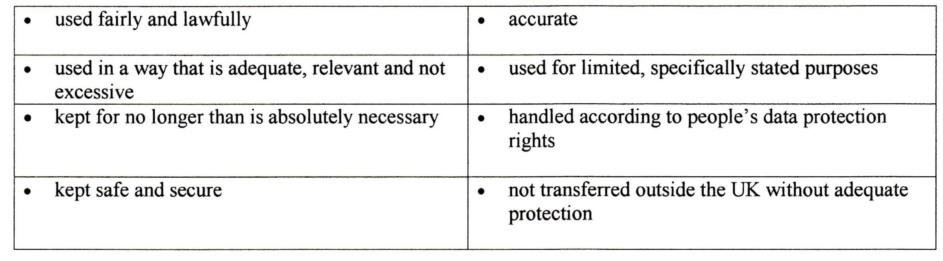
There is stronger legal protection (than in the past) for more sensitive information::


The implication for the way we must act is summed up by Shirley Bellinger (Swiss Re – 2005) who noted, the greater disclosure of information (as requested by the FSA) must be done in a diligent manner as “the insurance market does not have the same amount of data that could be shared, especially in commercial lines.” Regulators must be made aware that client confidentiality remains of paramount importance to insurance organisations.

For high street intermediaries, there has been a growth in electronic trading, using network links to insurers and EDI (electronic data interchange). In its simplest form it may involve exchange of information by email. EDI can also create an interface between intermediaries and insurers that provide pricing information and may be used to effect policy renewals and alterations. As technology develops, companies and law-makers must continually ensure that the privacy of client data or sensitive personal data is kept confidential to avoid conflicts of interest, without compromising policing operations. It means that insurance organisations must prove that all the data they collect are necessary for the assessment of risk – there are serious implications if the data are deemed to be used for future marketing purposes. Life insurers can hold data for decades at a time due to the nature of the policy; however the relevance of data collected at inception (or the distant past) must be justified as being relevant to the administration of the contract in the present day.
The insurer should avoid using personal data relating to policies that are no longer in force as according to the Act: “Data can be used only for the purpose specified when it was collected.” This means the data used for assessing risk cannot then be used for direct marketing purposes to get the business back after it has been lost.
As part of a budgeting process, insurance organisations may see a cost benefit to outsourcing some of their clerical / routine / low skill functions, sometimes even overseas. The danger is then surrounding data management and data security in transferring data overseas to companies in countries that perhaps do not have the same firewalls / anti-virus software that the parent company has. Our firm has a global encryption system with its own built-in firewalls to alleviate this issue. The Windows 7 upgrade now blocks the use of external USB devices to prevent any harmful viruses entering our system.
Our positive use of IT in a compliant, security conscious manner has resulted in the growth of E-Business and has produced benefits including:

From a data perspective, we (and all insurance organisations) must keep client data confidential and this requires a secure storage of data. One very effective method is in use, involving having both an intranet (for internal use in the offices by employees) and an extranet visible to clients (and insurers in a business to business capacity). This creates an effective separation of client data which is kept on the intranet. Effective anti-virus software is employed to prevent security breaches through the extranet to the intranet.
EDI (Electronic Data Interchange) is employed more by other insurers but is used by us to keep track of the progress of the placement of a risk, or a claim, through an insurer’s system. We can thereby keep the client well informed and ensuring customer service standards are upheld.

As mentioned, data security is paramount to an insurance organisation’s success and maintenance of reputation. Regulators also recognise this and have set out the International Standard ISO/IEC 27002 Code of Practice for Information Security, which all firms must adopt and senior management must ensure is in place. Sections include: 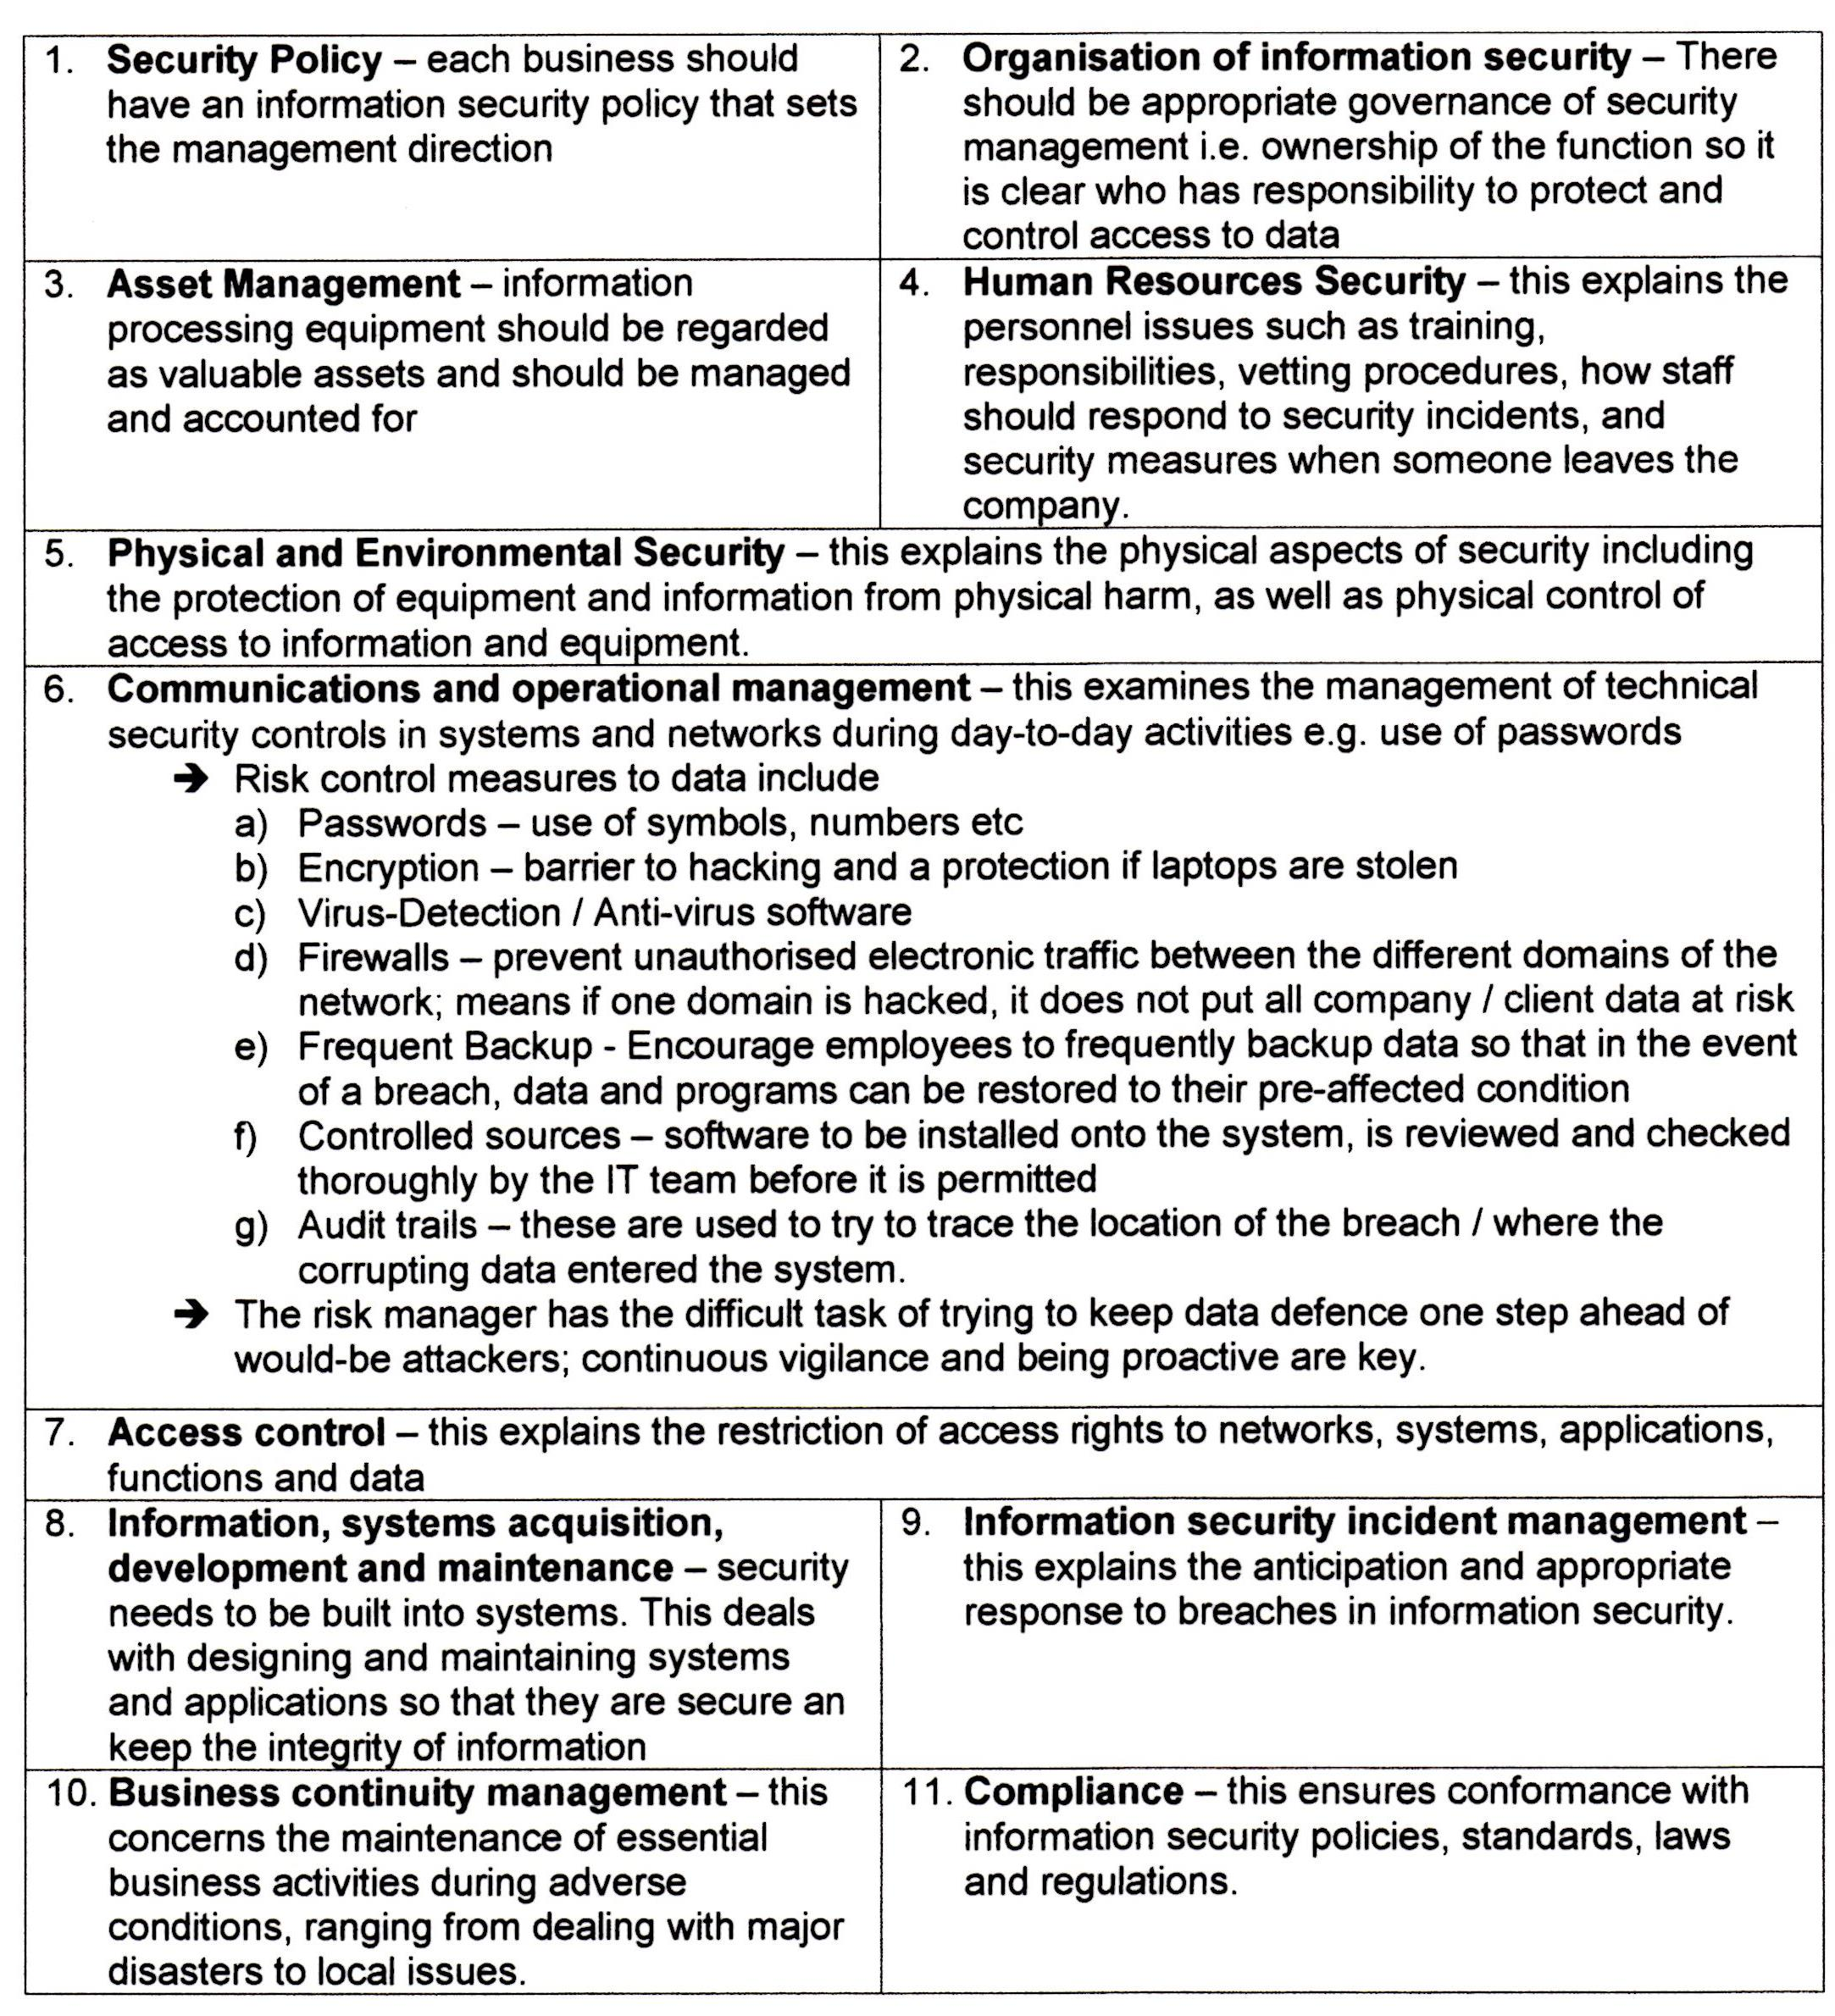
Our firm's responses include
- requirements surrounding length and characters within passwords,
- There are a number of different domains for employees to login into, each one must have a different password.
- There is also increased staff training, Windows 7 upgrade has just been rolled out and there have been sessions surrounding the changes as well as new passwords needing to be created.
- Care is taken in the way we advertise products to avoid mis-selling.
- In the event of a breach of data security, the relevant regulators should be notified promptly and it is good practice to involve the regulator in the action taken.
- These measures are in response to the FSA, published report entitled ‘Data Security in Financial Services’, which gives advice on data protection controls as well as managing third party suppliers and disposal of client data
- Customer Relationship Management (CRM) is at the heart of our long term profitability, focusing on in-depth customer knowledge to enhance the relationship in order to retain business, and exploit cross-selling opportunities. Data management and data integrity is vital to the success of this.

- The Bribery Act 2010 (and resultant anti-money laundering rules).
The Bribery Act enables courts and prosecutors to respond to bribes in the UK and abroad both in paying and receiving bribes.
From an insurance company’s point of view, they must be very careful of the following two offences:
This means that a company can be found guilty even if no one was aware of the bribery and individuals can face 10 years imprisonment and the company can be hit with a fine of unlimited magnitude.
Money laundering is associated with enacting bribes and is a crime under the Terrorism Act (2000) and the Proceeds of Crime Act (2002). The FSA (until 2007) had a specific sourcebook on the topic, but is now content to rely on the joint Money Laundering Steering Group (JMLSG) which has members from financial trade bodies with the aim of making life more difficult for criminals, while minimising the inconvenience and cost to firms and law-abiding customers. However there is still the necessity for us to have:
In conclusion, regulators are constantly evolving what they view as being the best path to sustainable development in the insurance industry; development that meets the needs of the present without compromising the ability of future generations to meet their own needs. Our greatest strength is our realisation of the need to work with regulators, not against them, to ensure the longevity of the business by being proactive in discussions of how best to maintain the reputation of the industry.

References

Books

Atkins, D. & Bates, I. (2012), Insurance Corporate Management, Chartered Insurance Institute.

Atkins, D. (2006), ‘Reputational Risk: A Question of Trust’, Global Professional Publishing.

Black, J. (2004), The Development of Risk Based Regulation in Financial Services: Canada, the UK and Australia, LSE

Financial Services Authority (2008), ‘Data Security in Financial Services’, Financial Crime and Intelligence Division

Liedtke, P et al. (2012), Insurance and Risk Solution in Light of the Systematic Risk Debate, The Geneva Association

Journal Articles

Friel, M (2011) News analysis - professionalism: brokers slow to embrace Aldermanbury Declaration, Insurance Age, 1st March 2011

Gordon-Walker, R (2007) ‘Throw out the rulebook’, www.postonline.co.uk 7th June 2007

Lloyd’s Release, ‘Solvency II Detailed Guidance Notes’, March 2010 pp. 1-28

McGagh, M (2009), ‘FSA to scrutinise consumer experience in shift to outcomes-based regulation’, Citywire, 19th March 2009, http://citywire.co.uk/new-model-adviser/fsa-to-scrutinise-consumer-experience-in-shift-to-outcomes-based-regulation/a333176

Taylor, M. (2008), ‘Overstretch at FSA’, Financial World, February 2008, p.17 www.financialworld.co.uk

Websites

Chartered Insurance Institute, (2010) Aldermanbury Declaration, http://www.cii.co.uk/about/aldermanbury-declaration/

Council of Mortgage Lenders (2007) Basel II - a guide to capital adequacy standards for lenders - http://www.cml.org.uk/cml/policy/issues/748

FSA, ‘High Level Standards’, http://fshandbook.info/FS/html/handbook/D3

FSA, ‘Insurance Conduct of Business Sourcebook’, http://fshandbook.info/FS/html/handbook/ICOBS

FSA, ‘Principles for Businesses’, http://fshandbook.info/FS/html/handbook/PRIN

Oxford English Dictionary online, www.oed.com

Penton, M (2013), ‘Has the Regulatory Pendulum swung too far?’, Lansons Communications, http://www.lansons.com/pages/has-the-regulatory-pendulum-swung-too-far

Stevenson, A (2012), ‘Queen blames 'lax' regulators for financial crisis’, 13th December 2012, http://www.politics.co.uk/news/2012/12/13/queen-blames-lax-regulators-for-financial-crisis

Parliamentary Acts

Data Protection Act 1998, http://www.legislation.gov.uk/ukpga/1998/29/contents

Financial Services and Markets Act, enacted 14th June 2000

Definition: Oxford English Dictionary online, www.oed.com
Definition Oxford English Dictionary online: www.oed.com
Atkins, D. & Bates, I. (2012), Insurance Corporate Management, Chartered Insurance Institute. Chapter 8, p. 3
The FSA/FCA/PRA have responsibility to respond to changes coming from EU legislation and reflect these in measures they require members of the UK financial sector to follow.
Atkins & Bates (2012), Insurance Corporate Management, Chapter 8 p. 31
Penton, M (2013), ‘Has the Regulatory Pendulum swung too far?’, Lansons Communications, http://www.lansons.com/pages/has-the-regulatory-pendulum-swung-too-far
Jones, M. (1996) Association of British Inurers.
Atkins & Bates (2012), Insurance Corporate Management, Chapter 8 p. 6
Basel II came into effect in the European Union on 1 January 2007 under the Capital Requirements Directive (CRD) and all lenders covered by the CRD have had to implement it from the beginning of 2008. Council of Mortgage Lenders (2007) Basel II - a guide to capital adequacy standards for lenders - http://www.cml.org.uk/cml/policy/issues/748
Black, J. (2004), The Development of Risk Based Regulation in Financial Services: Canada, the UK and Australia, LSE p. 23
Liedtke, P et al. (2012), Insurance and Risk Solution in Light of the Systematic Risk Debate, The Geneva Association p. 2
Gordon-Walker, R (2007) ‘Throw out the rulebook’, www.postonline.co.uk 7th June 2007
Stevenson, A (2012), ‘Queen blames 'lax' regulators for financial crisis’, 13th December 2012, http://www.politics.co.uk/news/2012/12/13/queen-blames-lax-regulators-for-financial-crisis
McGagh, M (2009), ‘FSA to scrutinise consumer experience in shift to outcomes-based regulation’, Citywire, 19th March 2009, http://citywire.co.uk/new-model-adviser/fsa-to-scrutinise-consumer-experience-in-shift-to-outcomes-based-regulation/a333176
Taylor, M. (2008), ‘Overstetch at FSA’, Financial World, February 2008, p.17 www.financialworld.co.uk
Atkins & Bates (2012), Insurance Corporate Management, Chapter 8 p. 4
Financial Services and Markets Act, enacted 14th June 2000
FSA, ‘High Level Standards’, http://fshandbook.info/FS/html/handbook/D3
FSA, ‘Insurance Conduct of Business Sourcebook’, http://fshandbook.info/FS/html/handbook/ICOBS
FSA, ‘Principles for Businesses’, http://fshandbook.info/FS/html/handbook/PRIN
Oil Insurance Limited, ‘OIL Technical Accreditation’, www.oil.bm
Lloyds and London Market Introductory Test, www.lloyds.com/LLMIT‎
Chartered Insurance Institute, ‘Award in London Market Insurance’, http://www.cii.co.uk/qualifications/award-in-london-market-insurance-qualification/
Atkins, D. (2006), Richard Lambert, editor of the Financial Times in ‘Reputational Risk: A Question of Trust’, Global Professional Publishing, p.70
Dudley Dean (2006)
My own contract
Atkins & Bates (2012), Insurance Corporate Management, Chapter 10 p. 22
Friel, M (2011) News analysis - professionalism: brokers slow to embrace Aldermanbury Declaration, Insurance Age, 1st March 2011
CII (2010) Aldermanbury Declaration, http://www.cii.co.uk/about/aldermanbury-declaration/
Lloyd’s Release, ‘Solvency II Detailed Guidance Notes’, March 2010.
Data Protection Act 1998, http://www.legislation.gov.uk/ukpga/1998/29/contents
Data Protection Act 1998, http://www.legislation.gov.uk/ukpga/1998/29/contents
Data Protection Act 1998, http://www.legislation.gov.uk/ukpga/1998/29/contents
Bellinger, S. (2005) in Atkins & Bates (2012), Insurance Corporate Management, Chapter 8 p. 11
Data Protection Act 1998, http://www.legislation.gov.uk/ukpga/1998/29/contents
International Organisation for Standardisation, ‘ISO/IEC 27002 Code of Practice for Information Security’, www.iso.org
Financial Services Authority (2008), ‘Data Security in Financial Services’, Financial Crime and Intelligence Division
Hawkes, V. (2000) in Atkins & Bates (2012), Insurance Corporate Management, Chapter 10 p. 11
Joint Money Laundering Steering Group, http://www.jmlsg.org.uk/

