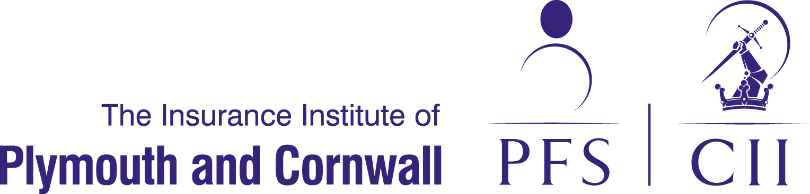

Full day of Training Workshops
Wednesday 20 April 2016
- Mixed Assessment Techniques
- Assignment Techniques
Mixed assessment techniques (half day course) MORNING 9.15am – 12.15 | Assignment techniques (half day course) AFTERNOON 1.00pm – 4.00pm
Overview  This course gives candidates best-practice guidance on how to tackle the mixed assessment required in certain CII Diploma subjects, including preparation for the assignments and addressing multiple-choice questions. | Overview  This course gives candidates best-practice guidance on how to tackle coursework assignments, which are now offered as an alternative assessment method for a number of CII Advanced Diploma in Insurance units.
Programme  - Breaking-down the assignment question  - Practical research  - Understanding the marking matrix  - Using multiple sources to answer assignments  - Layout, readability and style  - Finding sources that are current and relevant  - Framing insightful conclusions  - Understanding multiple-choice questions  - Strategies for eliminating the wrong answer  - Exam time management. | Programme  - Breaking down the assignment question  - Practical research  - Understanding the marking matrix and the implications for the assignment framework  - Using multiple sources to answer assignments  - Creating a high quality bibliography  - Layout, readability and style  - Finding sources that are current and relevant  - Framing insightful conclusions.
Learning outcomes  At the end of the course you will have gained:  - An appreciation of the CII Mixed Assessment Framework  - An understanding of how to research and structure the written assignment  - Experience in deconstructing the assignment question  - An understanding of how to build a good quality assignment  - An understanding of techniques to approach multiple choice questions  - Insight into the variable structures of multiple choice questions  - Some thoughts on time management | Learning outcomes  At the end of the course you will have gained:  - An appreciation of the CII Coursework Assignment Framework  - An understanding of how to research and structure the written assignments  - Experience in deconstructing the assignment question  - An understanding of the guidelines and constraints in writing and submitting assignments  - Familiarity with the CII's marking matrix  - An appreciation of the time management challenges
Who should attend?  Anyone completing one of the growing number of Diploma units where mixed assessment applies. It is also suitable for in-company group training. | Who should attend?  Anyone completing an Advanced Diploma in Insurance unit assessed by coursework assignments. It is also suitable for incompany training personnel wanting to gain an insight into the coursework assessment method, in order to provide guidance to employees.
CDP hours  Attendance of this course awards up to 3 CPD hours where you consider it relevant to your professional development needs. | CDP hours  Attendance of this course awards up to 3 CPD hours where you consider it relevant to your professional development needs.

