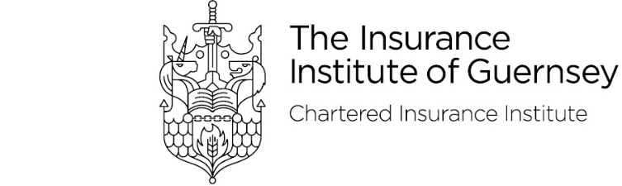

**Annual Dinner – Friday 17th October 2025**

Attendee Details

Details of guests and menu choices should be emailed to [iiglunch@islands.gg](mailto:iiglunch@islands.gg) by Monday 4th August 2025.

Please note that the start time of the dinner is 6.30pm and the bar will shut at 12am.

Place cards will be produced by the St Pierre Park based on the information provided below.

The dress code is Enchanted/ black tie or business Attire/ Dinner Dresses

|  |  |  |  |  |
| --- | --- | --- | --- | --- |
| **Guest Name** | **Starter** | **Main** | **Dessert** | **Dietary Requirements** |
|  |  |  |  |  |
|  |  |  |  |  |
|  |  |  |  |  |
|  |  |  |  |  |
|  |  |  |  |  |
|  |  |  |  |  |
|  |  |  |  |  |
|  |  |  |  |  |
|  |  |  |  |  |
|  |  |  |  |  |

Jodie Moore Cert CII, Insurance Institute of Guernsey

Dinner Secretary