MINUTES OF THE AGM OF,
THE INSURANCE INSTITUTE OF STOKE ON TRENT,
HELD OVER ZOOM VIDEO CONFERENCE,
at midday on 23rd April 2024

The AGM was advertised by eflyer and on our website. An agenda and nominations for Officer positions were provided online. The year end accounts were shared by email with attendees who had booked, providing the opportunity for anyone to raise any concerns.

The meeting was opened at which 12 Officers and Members were present.

- Apologies – Rachel Robinson, Peter Lycett

- The Minutes of the last AGM, having been circulated, were agreed by the Meeting.
There were no matters arising. The President signed the Minutes.

- Secretary’s Report.

A smoother running year I feel. Natalie has completed the first half of her two year term. We have delivered many CPD sessions alongside a few other events including a very successful Annual Dinner. Very recently we have also launched our Leadership Mentoring Programme.

Just a quick round up now under various headings.

Membership:
Membership numbers have fallen during 2023 which had been expected when we reported a year ago. As at 31 December 2023 our total membership was 638 (from 657). Within that number 375 were General Insurance members, 255 were Financial Services members and 8 were Mortgage Professionals.

We continue to be hampered by the CII’s stance on us emailing members. In recent months Howard has resumed contacting new members and these have also been invited to connect on LinkedIn if they are active there.

Education

Nola has provided the following report -

Exam Management information:
It has been disappointing to again not be able to gain the national insurance exam results from CII (suspect the reason for this has is ongoing system issues/upgrades). So, I have manually pulled together the following statistics based on CII website notes:
Certificate:
2022 pass rate
FIT 69%
IF1 69%
IF2 72%
IF3 74%
IF4 73%
IF5 71%
IF6 76%
IF7 76%
IF8 80%
IF9 80%
I10 74%
I11 87%
LM1 84%
LM2 72%
LM3 84%

NB: for Advanced diploma units CII have the following statement:
The average pass rate for those completing Diploma in Insurance mixed assessment units in full is currently 92.0%
Results for PFS 2022 exam sittings were as follows:
Diploma:
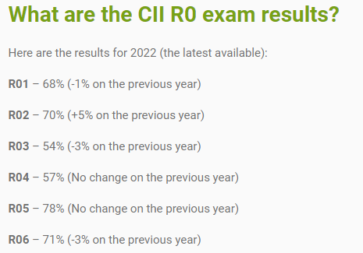
Advanced Diploma:
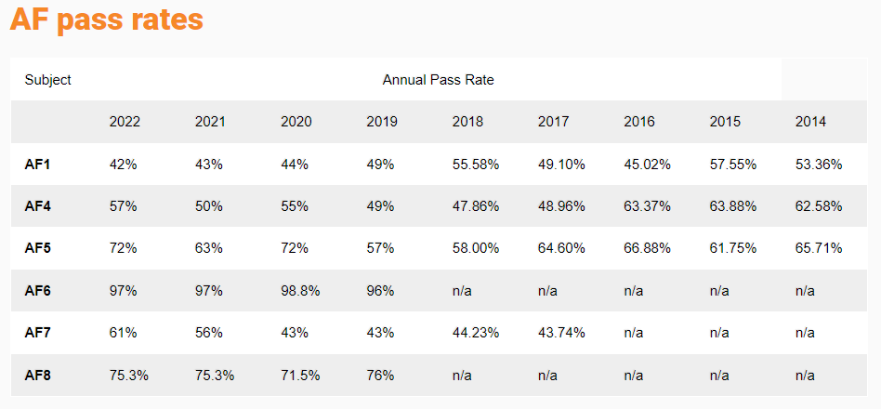

I believe we have now access to the exam results for our local area, but I have not yet seen this report.
Issues around remote invigilation exam sittings remains ongoing:
Hardware/Software/Wi-Fi – the following CII website message remains in place:
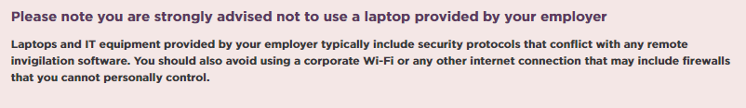
The local CII exam centre (Nantwich) has now closed
Further to the closure of the CII exam centre in Nantwich (late 2023), those taking exams utilising a CII exam centre will now have to travel to a PSI run centre, the nearest ones (based on an ST4 postcode) will be:
PSI Manchester (approx. 34 miles)
PSI Birmingham (approx. 38 miles)
PSI Nottingham (approx. 43 miles)
We have raised this as an issue with Sean O’Keefe (CII Business Development Executive) on 20/03/24.
Cert CII Fast Track 2024 Programme
Spear headed by the CII Leicester Institute; we joined an initiative to provide a CII Qualifications programme (see e-flyer detailed below). The cost to our institute was £95 per candidate with the expectation that employers would fund the study text and exam entry and provide the time off to attend the nine three-hour online training sessions.
Four local candidates were successful in gaining a place (Andree Nicholson (AJ Gallagher), James Hawkins (Insurance Connections), Katy Handley-Dean (Davies) and Marie Howell
(Davies) and the programme started on 8th January 2024 with the last session running on 18th March 2024.
As Education Secretary I will be contacting these candidates in April 2024 to see how they are progressing and if any additional support can be provided to enable them to achieve their Certificate in Insurance qualifications.
It should be noted that the original intention was for the initiative to extend to the Diploma and Advanced Diploma in Insurance, however due to insufficient uptake, this will now not happen.

Nola also took on responsibility for the Young Achiever Award which was very well received by local employers and drew a good number of nominations.

Following on from the Award, Vice President Angela Henry once again arranged a lunch at The Potters Club for us to further celebrate our rising stars.

Lunchtime Syllabus meetings - these mostly continued online but we continue to aim for occasional face-to-face events.

Our Deputy President, David Smith, and the Syllabus sub-committee, have done an amazing job in organising a full calendar of 8 monthly meetings which have been well received by those attending. Feedback from members has overall been very positive.

Once again we made use of the CII promoted speakers on varied topics alongside local business people. Attendance numbers are holding steady.

There is no major change to the system of CPD Accreditation. Following on from the in-depth audit last year, in which we were one of a handful of local institutes chosen to participate, we are required this year to supply copies of slides from two sessions as part of our Annual Returns. We must continue to ensure our events are correctly publicised and always include stated Learning Objectives.

Annual Dinner – this was held on 15 September. Craig Roberts and Angela Henry did a remarkable job and delivered a very enjoyable event. The President’s chosen charity was Survive and £1750 was raised from the raffle on the night. Once the final accounts were completed the surplus was £2277.99 and this was split equally between Survive and The Insurance Charities.

Charities – unfortunately we still do not currently have a Charities Representative. Sue has taken on the responsibility of maintaining contact with The Insurance Charities and publicising their activities.

Sadly fundraising for The Insurance Charities has been a casualty of our CPD meetings being mostly online. Therefore our donations this year consist almost solely of the £1138.99 mentioned above.

Sports – Thanks go to Simon Allman who as Sports Secretary has organised a few events over the past year and has provided me with the Summary of events over the last 12 months as follows, there was the welcome return of the regular events :-

- Pool Tournament took place on 28th June 2023
- Snooker Tournament took place on 28th February 2024

Plans are being discussed for a darts tournament. We are also considering cricket and golf events.
Suggestions from members for any other events of interest are always welcome.

Publicity – Primarily, we use our CII website and eflyer system to publicise our events, Syllabus meetings, and news items. We have also been making increased use of our group page on LinkedIn.
The booking system on the website is now well established and members have embraced its use.

Our website will be updated in due course with details of the new Council positions.

We’re very sorry this year to be losing from Council – Kate Evans. Kate has this past year assisted with the Publicity tasks and we thank her for her service on Council this past couple of years.

A special mention goes to Kate Barnard who took on the Treasurer role this year and I thank her for the smooth transition. We will hear her annual report next.

Regrettably we have not secured any new Council members for the coming year, although we do have a few people in prospect who may join us at a later stage.

However, I feel we are going into a new year with our established strong team. They are enthusiastic and dedicated to providing the best possible experience for our members.

- Treasurer’s Report.

I can confirm that our accounts for the year ending 31st December 2023 have been circulated to the committee.
They have been reviewed by our qualified accountant Karen Lewis and signed off on the 22nd March 2024.
Key Points
Total expenditure for the year was £22,800.29 of which £12,699.51 was annual dinner costs.
Total income for the year was £19,103.00. This was made up of the ordinary grant and annual dinner income. There was no further grant available due to our reserves.
Due to events being more face to face CPD and educational activities costs were increased to £4,602.74 compared to virtually 0 in 2022.
This resulted in a loss for the year of -£3,697.
The dinner surplus was £2,277.99 which was split between two charities, survive and The Insurance Charities.
The bank balance at the end of December 2023 was £8,817.02 with no uncleared transactions.
Training and mentoring initiatives are being offered to make use of our funds.

- Election to Office.

The following Members were elected to Office, having been nominated and voted on by Council at a meeting on 19 April 2023.

President: Natalie Briggs
Deputy President: David Smith
Vice Presidents: Viv Gilroy*
(*Ex. - Officio Members of Council) Angela Henry* Sue Spruce
Secretary: Sue Spruce
Treasurer: Kate Barnard
Charities Secretary:
Education Secretary: Nola Craig
Dinner Secretary: Craig Roberts
Public Relations Officer: Sue Spruce
Sports Secretary: Simon Allman
Membership Secretary: Howard Ball
Regional Forum Officer: Alasdair Buchanan
Diversity Co-Ordinator Rachel Robinson

- Election of Council.

The following Members, having been correctly nominated were elected to Council:
Sarah MacDonald, Grant Williams, Peter Lycett, Nicole McGade

A professional auditor – Karen Lewis – is appointed.

- Installation of President.

Natalie Briggs installed as President for 2024/2025.

Natalie addressed the meeting with her thanks to Council and thoughts on the coming year.

- Any Other Business.

Next Council meeting: 15 May 2024 on Zoom

2025 AGM – 29 April

Sue Spruce, Secretary
6 May 2024

