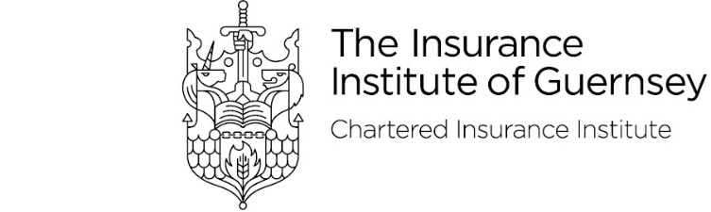

Annual Dinner – Friday 13th October 2023
Attendee Details

Details of guests and menu choices should be emailed to iiglunch@islands.gg by Friday 29th September
Please note that the start time of the dinner is 6.45pm and the bar will shut at 12pm.
Place cards will be produced by the Duke of Richmond based on the information provided below
The dress code is black tie or business Attire/ Dinner Dresses

Guest Name | Starter | Main | Dessert | Dietary Requirements

Jodie Moore & Harry Rendall, Insurance Institute of Guernsey
Dinner Secretaries

