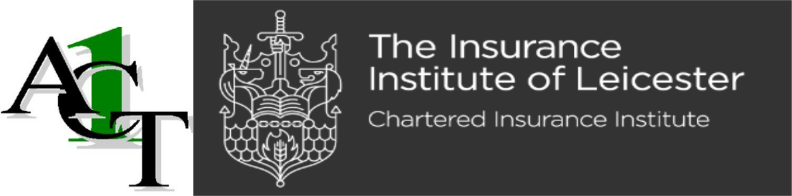
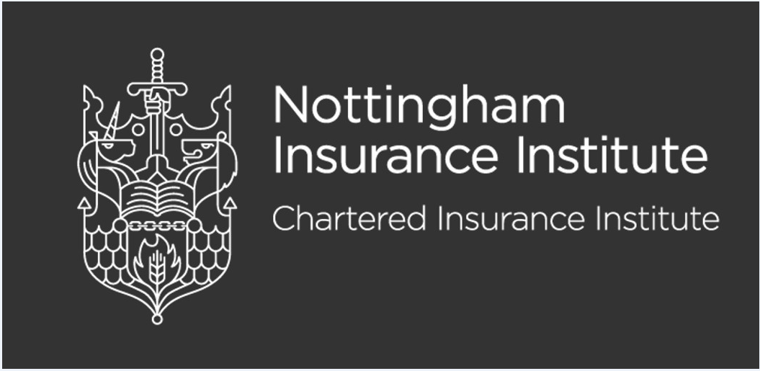

Certificate in Insurance – I10 Insurance Broking Fundamentals. Fast-track application form. May 2023.

To book a place on the fast-track course, please complete this form

First name:
Surname:
Employer’s name:
Employer’s address:
Your contact details:
Email address:
Mobile telephone number:
Are you a member of the CII? | Yes/No
Please state your CII PIN:

Have you enrolled for the I10 exam with CII?  If ‘No’, what is the state of your application? | Yes/No
Have you taken the I10 exam before?  If so, when? | Yes/No
Do you have your manager’s approval to attend the six two-hour lunchtime sessions? | Yes/No/Not Required
Name of manager:
Do you know your learning style? | Visual/Audio or Kinaesthetic?
Which other Certificate subject units are you
considering next after I10, if any?

Places on the fast track I10 course are limited, so candidates must commit to attend ALL of the six virtual zoom seminars. Candidates are also expected to study in their own time, between seminars and complete activities set for them.

During the live seminars, cameras are to be on to maximise interaction and to promote learning.

