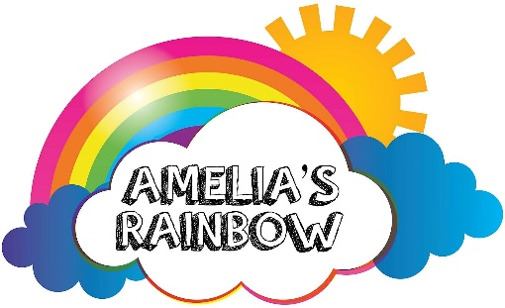

21 Daws Avenue
Bournemouth
BH11 8SB

30 July 2026

Nicki Lenton
Insurance Institute of Bournemouth

Dear Nicki

We are writing to express our most sincere thanks to everyone involved in the recent Golf Event and the resulting amazing donation of £1,300 to Amelia’s Rainbow. Your support of our charity is so greatly appreciated and this has made a significant impact on our fundraising for the year. Would you please pass on our gratitude to everyone involved.

Our charity supports children in Dorset and the surrounding area who have terminal, life limiting, serious and chronic illnesses, to enable them to have fun and create cherished memories with their families, by providing funds for toys, games, electronic equipment, days out, special trips and other ways in which their lives can be enhanced and enjoyed, through difficult times. Last year we were able to give gifts to 49 children and the number increases every year.

In addition, the Charity has a Holiday Home at New Milton, in which families can stay free of charge, giving them a much-needed break away from home, it was full for most of 2018. We also have a Beach Hut in Southbourne, which is available for families to use. Our Christmas Appeal resulted in donations of hundreds of gifts which were delivered by our volunteers to 178 children all over Dorset and to children who were in Poole Hospital on Christmas Day and Dorchester Hospital on Boxing Day.

All our income is from fundraising, sponsorship and donations so without the wonderful support we have received all this would not be possible.

Once again, please accept our sincere thanks,

Kindest regards

Maureen Cox
Treasurer

