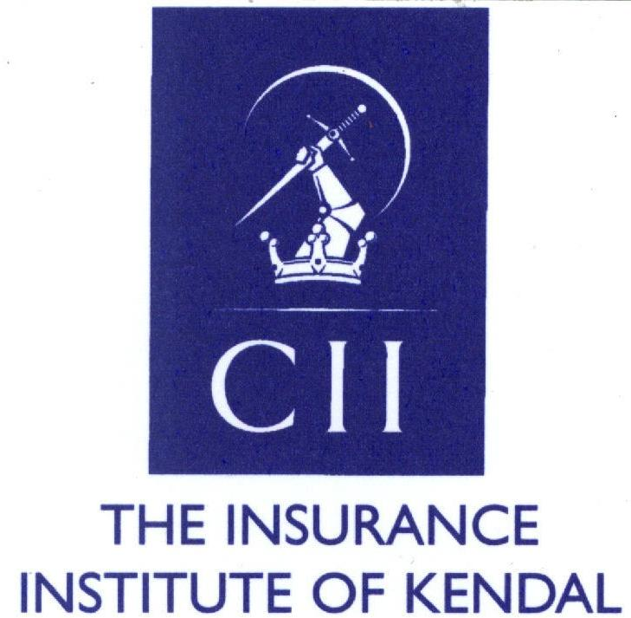
65th Annual Dinner of the Insurance Institute of Kendal

Friday 27st February 2015
The Netherwood Hotel, Grange over Sands, LA11 6ET 7.00pm for 7.30pm

Name:.............................................................................................................................................
Email: ............................................................................................................................................
Phone no.: .....................................................................................................................................
Please reserve…………places at £ 39 each at the Annual Dinner on Friday 27th February 2015.

Please reply by 10th February 2015.

I enclose £…………. (Total). Cheques payable to “The Insurance Institute of Kendal”

Please print the names of your party clearly in full below so that we may print place cards.
Continue overleaf if necessary. Please indicate any special dietary requirements, there will be a vegetarian option for the main course.

……………………………………………………………………………………………………………………
……………………………………………………………………………………………………………………
……………………………………………………………………………………………………………………
……………………………………………………………………………………………………………………
…………………………………………………………………………………………………………………...
……………………………………………………………………………………………………………………
……………………………………………………………………………………………………………………
……………………………………………………………………………………………………………………
……………………………………………………………………………………………………………………
……………………………………………………………………………………………………………………
Please reply to Cath Evans, Dinner Secretary cathward00@gmail.com or cath.ward@allianz.co.uk
Flat 1 Eggerslack House, Windermere Road, Grange Over Sands, Cumbria LA11 6EX

